Question 1:
Imagine a teacher has a gradebook for 3 classes, with each class having 4 students. The teacher wants to find the average score for each class.
Class 1: 85, 92, 78, 90
Class 2: 88, 76, 95, 84
Class 3: 90, 85, 88, 92
Calculate and show the average score for each class.
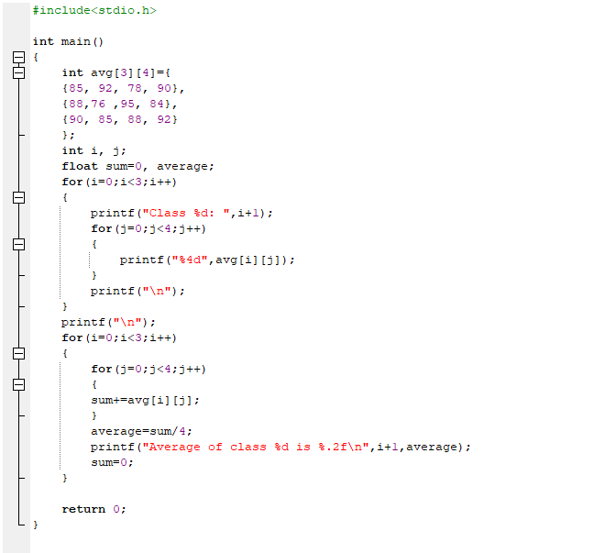
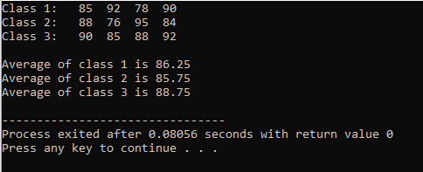
Question 2:
A family has a photo album organized by year and then by month. They want to list how many photos they took each month for the last 2 years.
Year 1: 12, 10, 15, 8, 5, 20, 25, 30, 10, 5, 8, 15
Year 2: 10, 12, 18, 9, 6, 22, 28, 35, 12, 7, 9, 16
Print the number of photos for each month of each year.
Output:

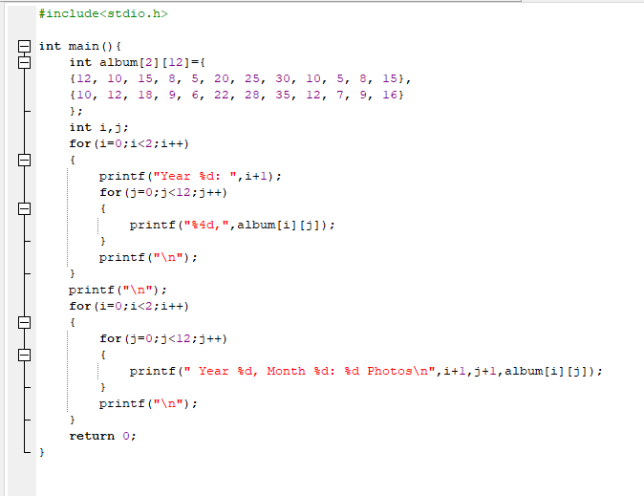
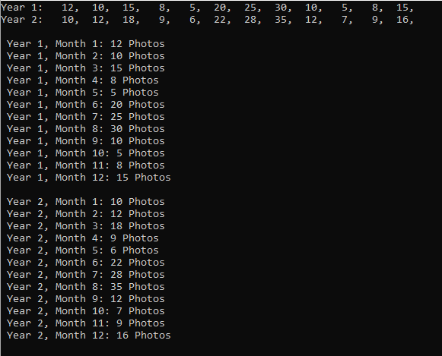
Question 3:
Create a program that works with a small 4x4 black and white image. The program should:
Create an original image where 1 represents white pixels and 0 represents black pixels
Display the original image
Create an inverted version (negative) of the image where white becomes black and black becomes white
Display both images side by side
Count how many white pixels are in the original image
Original Image 4x4:
{1, 0, 1, 0},
{0, 1, 0, 1},
{1, 1, 0, 0},
{0, 0, 1, 1}
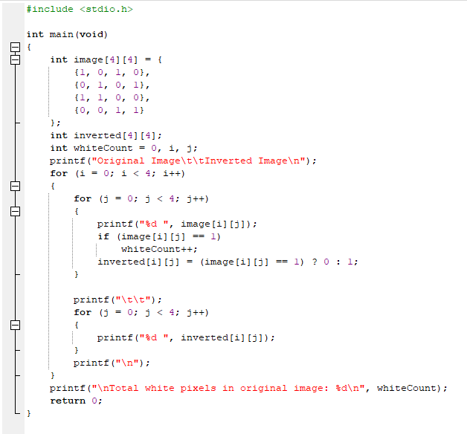
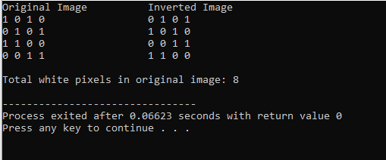
Question # 4
A small cinema has 3 rows with 3 seats in each row. The booking system marks a seat as 1 if it's booked and 0 if it's available. Find the total number of available seats and list their positions.
Row 1: 1, 0, 1
Row 2: 0, 0, 1
Row 3: 1, 1, 0
Count all available seats and print their row and seat number.
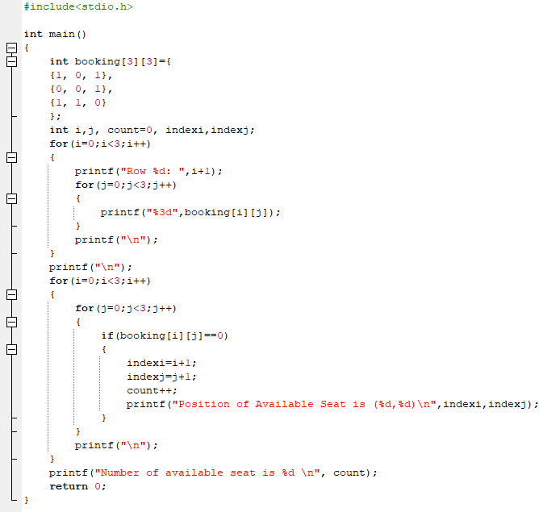
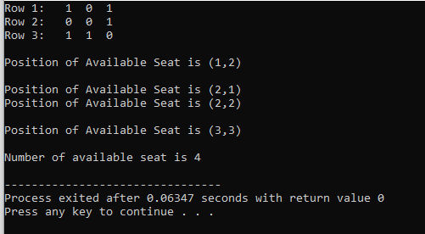
Question # 5
A research team has placed sensors in a mountain valley arranged in a grid. Each sensor records the daily temperature. They need to find all "cold spots" - sensors where the temperature is lower than all of its immediate neighbors (to the north, south, east, and west). Sensors at the edge of the grid have fewer neighbors.
Grid of Temperatures (°C):
12, 15, 10, 9
11, 8, 12, 13
14, 13, 9, 7
16, 11, 10, 8
Find and report the location (row, column) and temperature of all cold spots. A cold spot must be colder than all its existing adjacent neighbors.
Output:
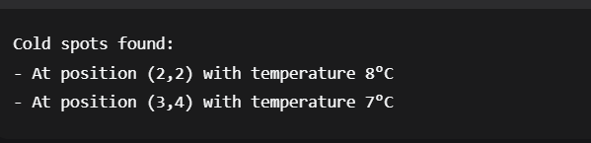
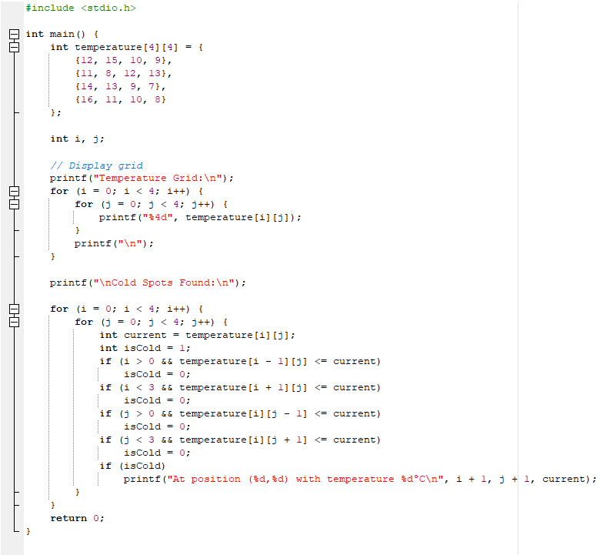
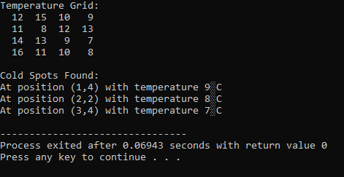

Question # 6
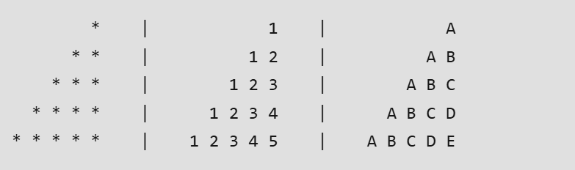
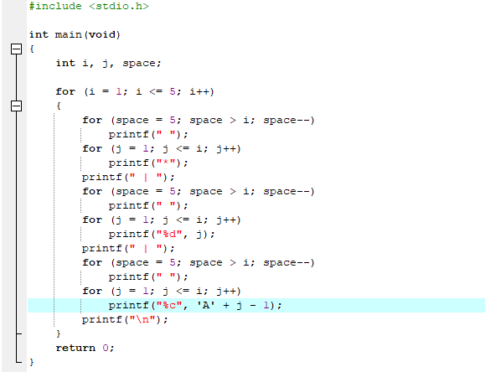
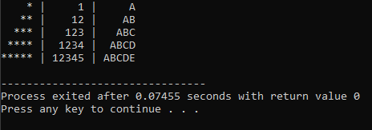
Question # 7
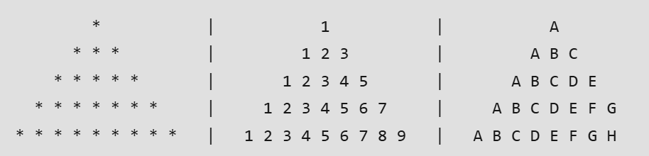
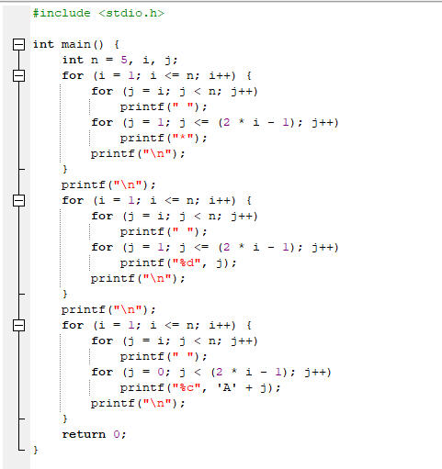
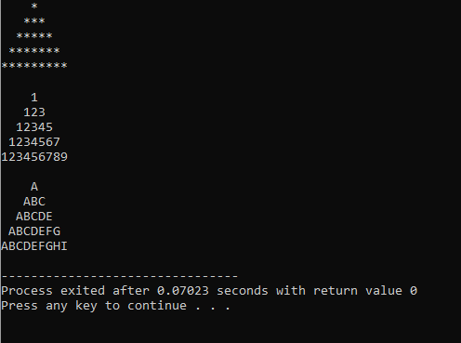
Question # 8
A teacher needs to organize seating for students in a classroom that has 5 rows with 5 desks in
each row. Create a program that shows which desks are occupied and which are empty.
The seating should follow this pattern: students sit in every other desk, creating a checkerboard-
style arrangement where occupied desks are separated by empty ones.
The program should display the final seating chart showing exactly where students are sitting.
